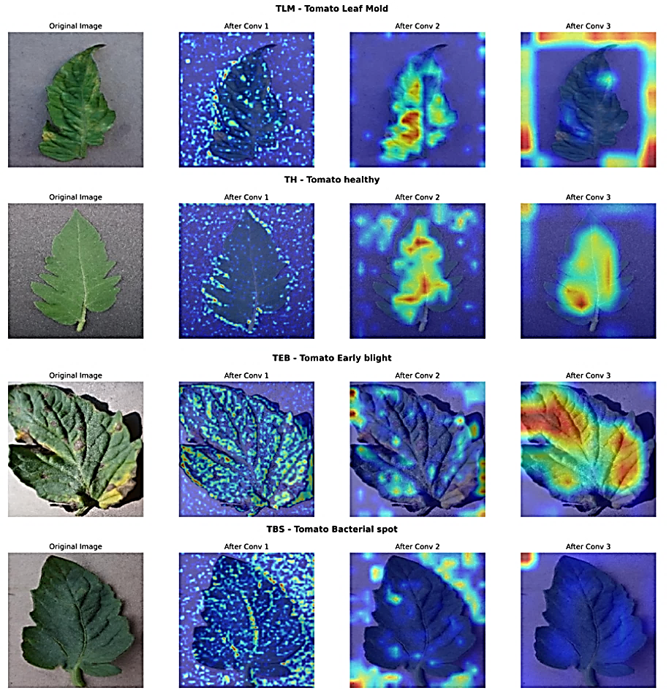
Figure 4.2 Feature Extraction Visualization of Tomato Leaves

